FIRM FOUNDATION
Psalm 27 Isaiah 33:5-6 Luke 6:46-49

SHIFTING TIMES, SHIFTING FOUNDATIONS
____________________________________________________________________________________________

THE FIRM FOUNDATION REVEALED ISAIAH 33:5-6
__________________________________________________________________________________________________________________________________________
______________________________________________

FIRM FOUNDATION UNDERSTOOD LUKE 6:46-49
________________________________________________________________________________________________________________________________________________________________________________________
COME ________________________________________
______________________________________________
LISTEN ________________________________________
______________________________________________
FOLLOW, OBEY _________________________________
______________________________________________

FIRM FOUNDATION
Psalm 27 Isaiah 33:5-6 Luke 6:46-49

SHIFTING TIMES, SHIFTING FOUNDATIONS
____________________________________________________________________________________________

THE FIRM FOUNDATION REVEALED ISAIAH 33:5-6
__________________________________________________________________________________________________________________________________________
______________________________________________

FIRM FOUNDATION UNDERSTOOD LUKE 6:46-49
________________________________________________________________________________________________________________________________________________________________________________________
COME ________________________________________
______________________________________________
LISTEN ________________________________________
______________________________________________
FOLLOW, OBEY _________________________________
______________________________________________

TO CONTINUE THE CONVERSATION
1. What is your real foundation? How do you know?
2. COME. LISTEN. FOLLOW/OBEY. Which of these three do you need to pay more attention to? What will you do about it? What help do you need?

3. Was there a song or phrase that caught your attention today? What might the Lord be saying to you in those words?

4. Think about the closing question from the message today: If you were arrested for being a Christian, would there be enough evidence to convict you? C.S. Lewis
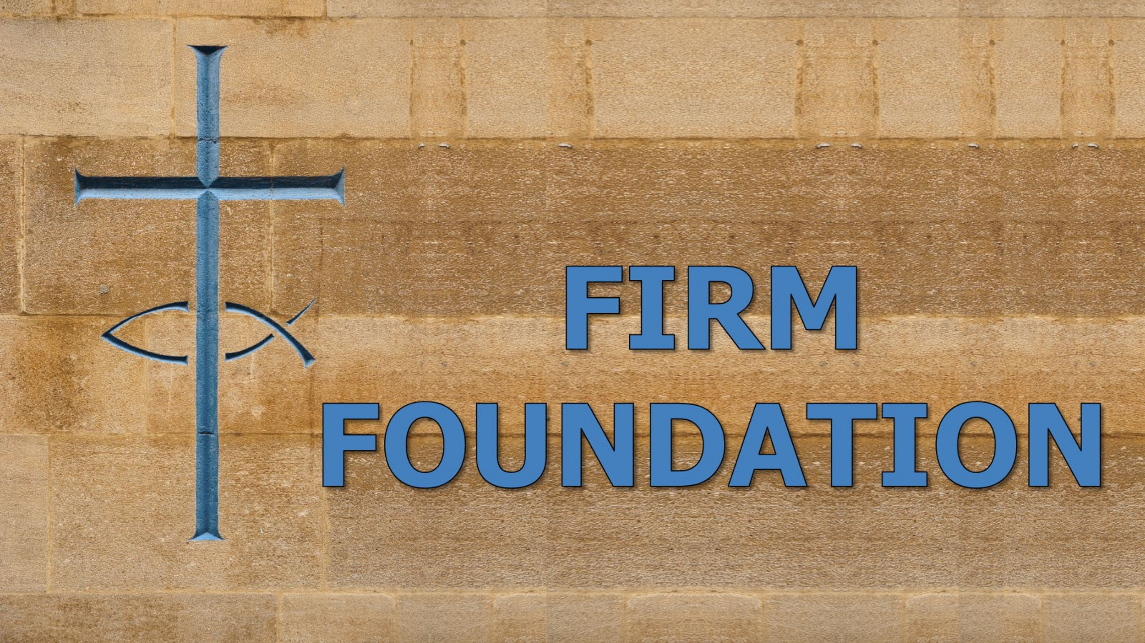

TO CONTINUE THE CONVERSATION
1. What is your real foundation? How do you know?
2. COME. LISTEN. FOLLOW/OBEY. Which of these three do you need to pay more attention to? What will you do about it? What help do you need?

3. Was there a song or phrase that caught your attention today? What might the Lord be saying to you in those words?

4. Think about the closing question from the message today: If you were arrested for being a Christian, would there be enough evidence to convict you? C.S. Lewis

