FIRM FOUNDATION #4
Selected scriptures

JESUS and PRAYER _____________________________
_____________________________________________
_____________________________________________
_____________________________________________
_____________________________________________
JESUS TAUGHT HOW TO PRAY _____________________
_____________________________________________
_____________________________________________
_____________________________________________
THE PRAYER THAT NEVER FAILS __________________
____________________________________________
BEGINNERS IN PRAYER_________________________
____________________________________________
____________________________________________
TALKING TO GOD ______________________________
TALKING WITH GOD____________________________
LISTENING TO GOD_____________________________
BEING WITH GOD______________________________
P.R.A.Y.
FIRM FOUNDATION #4
Selected scriptures

JESUS and PRAYER _____________________________
_____________________________________________
_____________________________________________
_____________________________________________
_____________________________________________
JESUS TAUGHT HOW TO PRAY _____________________
_____________________________________________
_____________________________________________
_____________________________________________
THE PRAYER THAT NEVER FAILS __________________
____________________________________________
BEGINNERS IN PRAYER_________________________
____________________________________________
____________________________________________
TALKING TO GOD ______________________________
TALKING WITH GOD____________________________
LISTENING TO GOD_____________________________
BEING WITH GOD______________________________
P.R.A.Y.
TO CONTINUE THE CONVERSATION
- Take a look at the resources Pastor Chris has available today, and try one this week as you pray.
- Pray using the P R A Y guide.
- What is the hardest thing for you about praying?
- What did today’s message, scriptures, songs, children’s time spark in you about prayer?
- What prayer practices will you try this week?

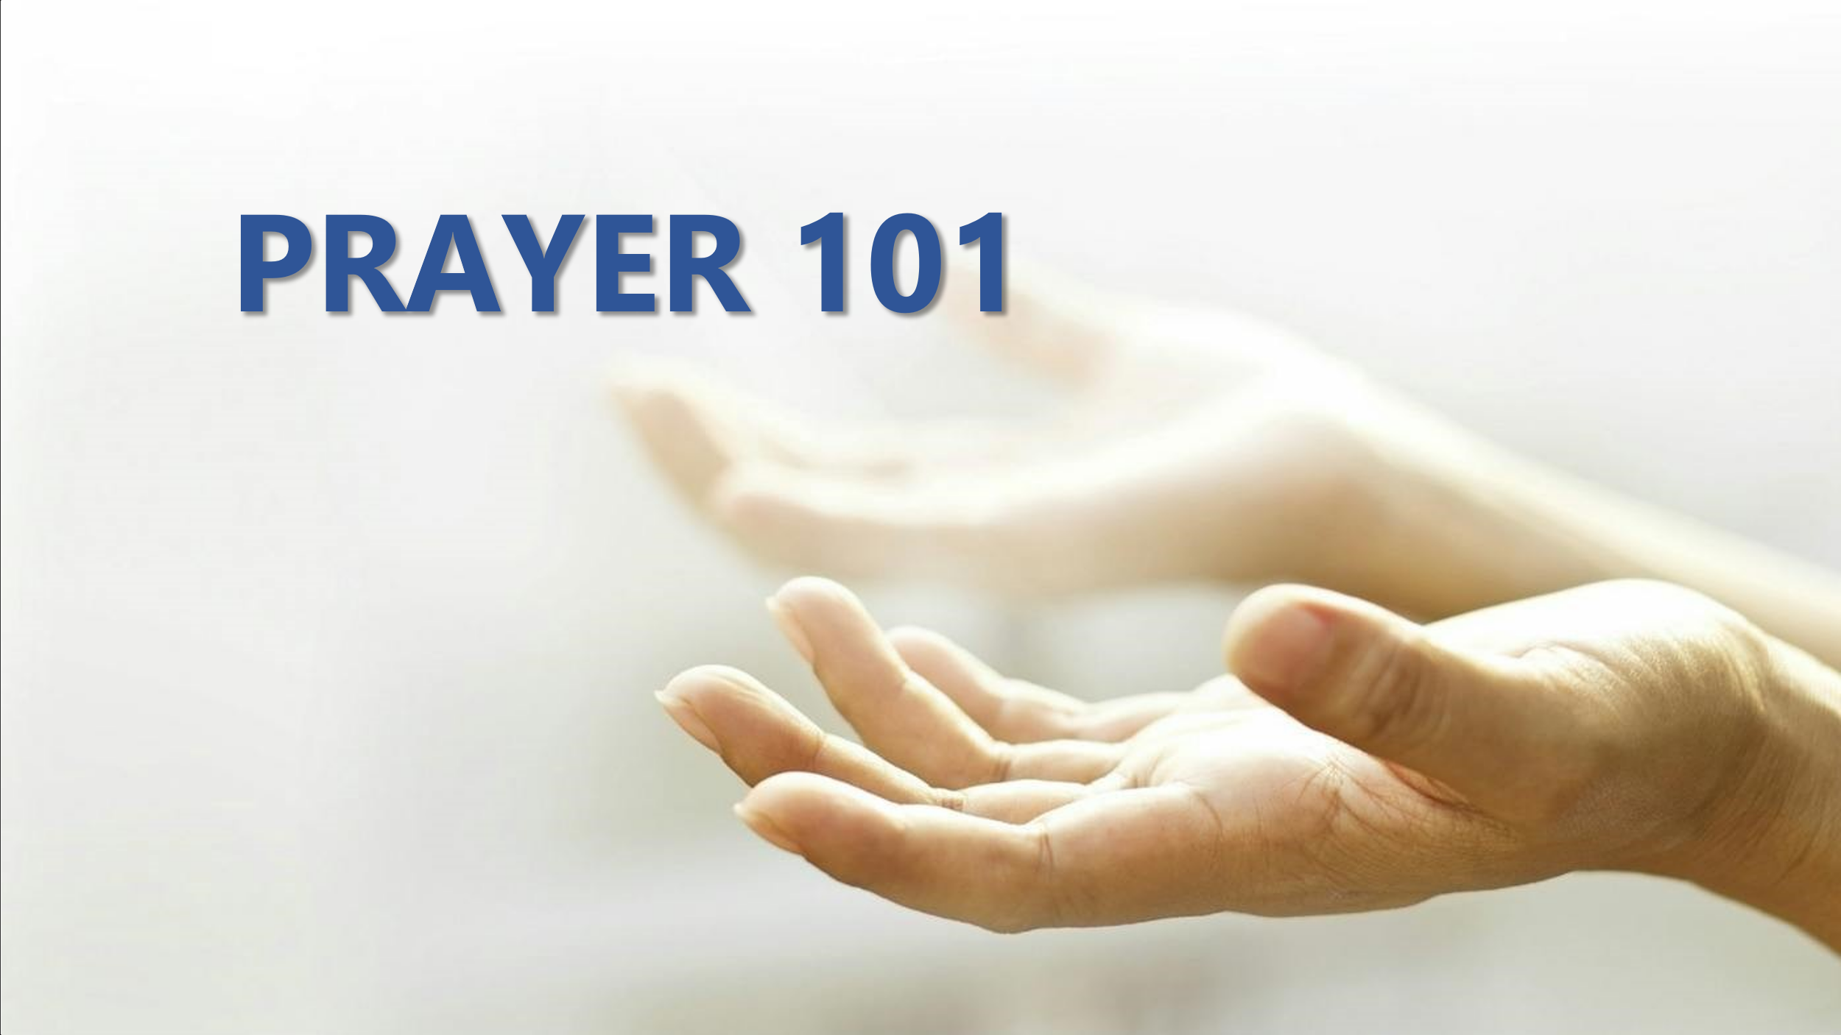

TO CONTINUE THE CONVERSATION
- Take a look at the resources Pastor Chris has available today, and try one this week as you pray.
- Pray using the P R A Y guide.
- What is the hardest thing for you about praying?
- What did today’s message, scriptures, songs, children’s time spark in you about prayer?
- What prayer practices will you try this week?

