PRAY LIKE JESUS #2: LOCATION
Isaiah 40:25-31 Psalm 33 Colossians 1:15-20 Matthew 6:5-13

Our Father ___________________________________
____________________________________________
Who art in heaven ____________________________
____________________________________________
____________________________________________
____________________________________________
____________________________________________
____________________________________________
____________________________________________
____________________________________________
____________________________________________
____________________________________________
What this means in daily life ____________________
___________________________________________
____________________________________________
____________________________________________
____________________________________________
____________________________________________
____________________________________________
____________________________________________
____________________________________________

PRAY LIKE JESUS#2: LOCATION
Isaiah 40:25-31 Psalm 33 Colossians 1:15-20 Matthew 6:5-13

Our Father ___________________________________
____________________________________________
Who art in heaven ____________________________
____________________________________________
____________________________________________
____________________________________________
____________________________________________
____________________________________________
____________________________________________
____________________________________________
____________________________________________
____________________________________________
What this means in daily life ____________________
___________________________________________
____________________________________________
____________________________________________
____________________________________________
____________________________________________
____________________________________________
____________________________________________
____________________________________________

TO CONTINUE THE CONVERSATION
- What images of heaven did you grow up with? How might your understanding of heaven grow as you pray the Lord’s Prayer this week?
- Where do you get “stuck” or confused in your image of God?
- What hymns or songs help you see God as “bigger”? heaven as more than ‘someday’?
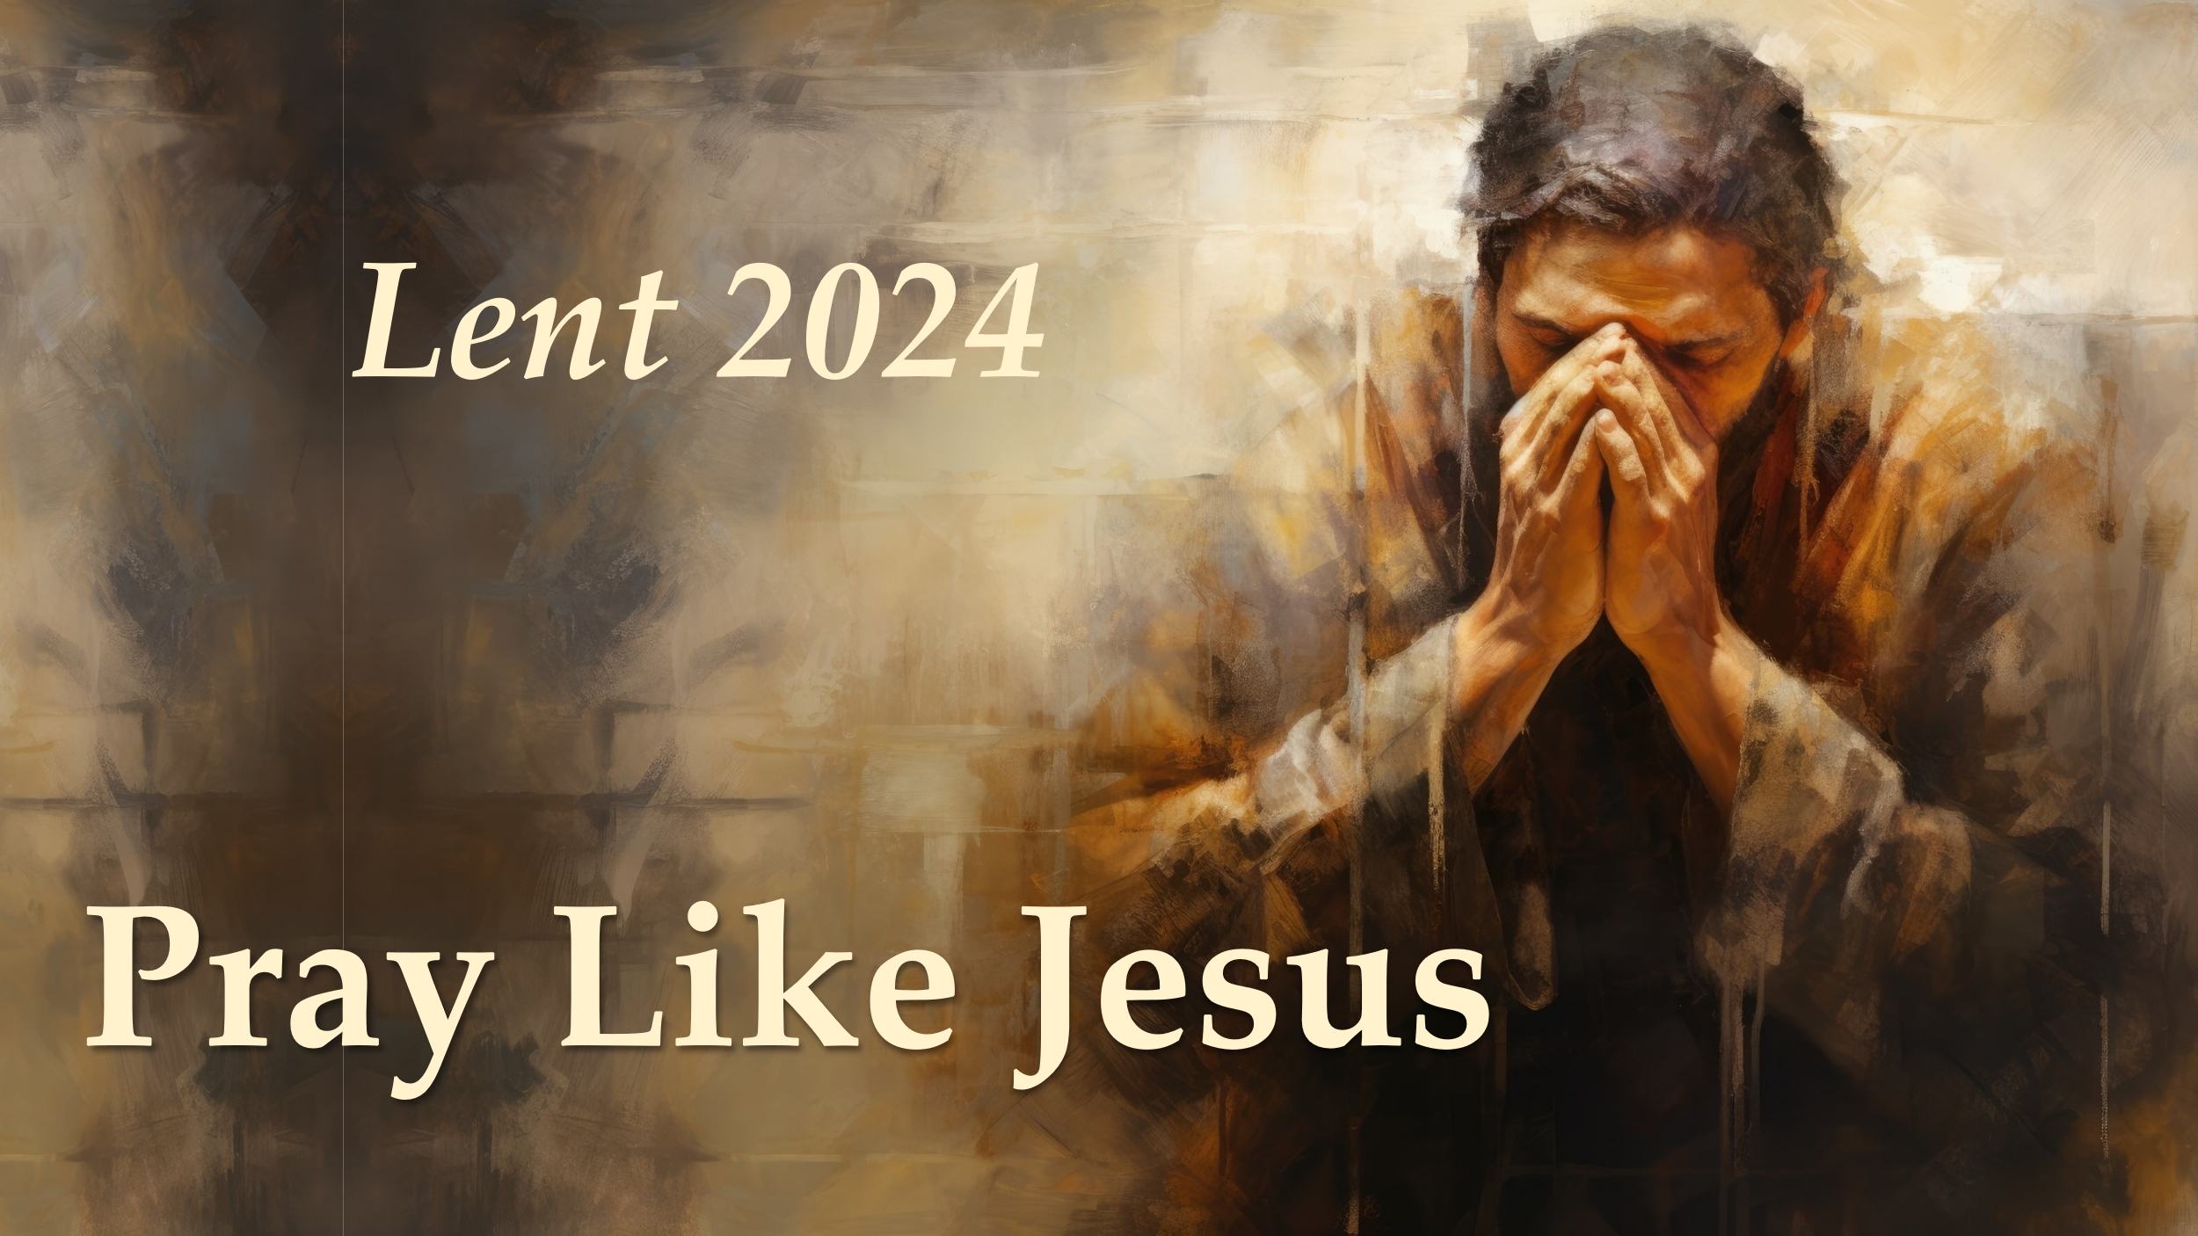
- This week, day or night, be on the lookout for “God-sightings” that help you expand your sense of the Lord’s presence and power and love for you. Perhaps look at the stars one night; a sunrise or sunset; tundra swans silhouetted against the sky; or holding a baby. Re-read the scriptures from today. Pause on the praise “who art in heaven” as you pray the Lord’s Prayer this week.

TO CONTINUE THE CONVERSATION
- What images of heaven did you grow up with? How might your understanding of heaven grow as you pray the Lord’s Prayer this week?
- Where do you get “stuck” or confused in your image of God?
- What hymns or songs help you see God as “bigger”? heaven as more than ‘someday’?
- This week, day or night, be on the lookout for “God-sightings” that help you expand your sense of the Lord’s presence and power and love for you. Perhaps look at the stars one night; a sunrise or sunset; tundra swans silhouetted against the sky; or holding a baby. Re-read the scriptures from today. Pause on the praise “who art in heaven” as you pray the Lord’s Prayer this week.

