PRAY LIKE JESUS #4: KINGDOM
Isaiah 11:6-9 Psalm 145:1-13a Revelation 21:3-5
‘KING’___________________________________________________________________________________
____________________________________________
____________________________________________
____________________________________________
KINGDOM HERE AND NOW – AND NOT YET
____________________________________________
____________________________________________
____________________________________________
____________________________________________

When we pray ‘Thy Kingdom come’…. ____________________________________________
____________________________________________
____________________________________________
____________________________________________
The difference Thy Kingdom come makes….
____________________________________________
____________________________________________
____________________________________________
____________________________________________
PRAY LIKE JESUS #4: KINGDOM
Isaiah 11:6-9 Psalm 145:1-13a Revelation 21:3-5
‘KING’___________________________________________________________________________________
____________________________________________
____________________________________________
____________________________________________
KINGDOM HERE AND NOW – AND NOT YET
____________________________________________
____________________________________________
____________________________________________
____________________________________________

When we pray ‘Thy Kingdom come’…. ____________________________________________
____________________________________________
____________________________________________
____________________________________________
The difference Thy Kingdom come makes….
____________________________________________
____________________________________________
____________________________________________
____________________________________________
TO CONTINUE THE CONVERSATION
1. What are two ‘take away’ ideas you heard today? Things you want to think about more?

2. Who is on the throne in your life? In your raying, noticing, reflecting this week, call upon King Jesus and seek His grace and guidance.

3. As you reflect on your own life, what relationships, decisions, realties, hopes and dreams might you do well to look at ‘with two eyes’ here and now, and there and not yet?
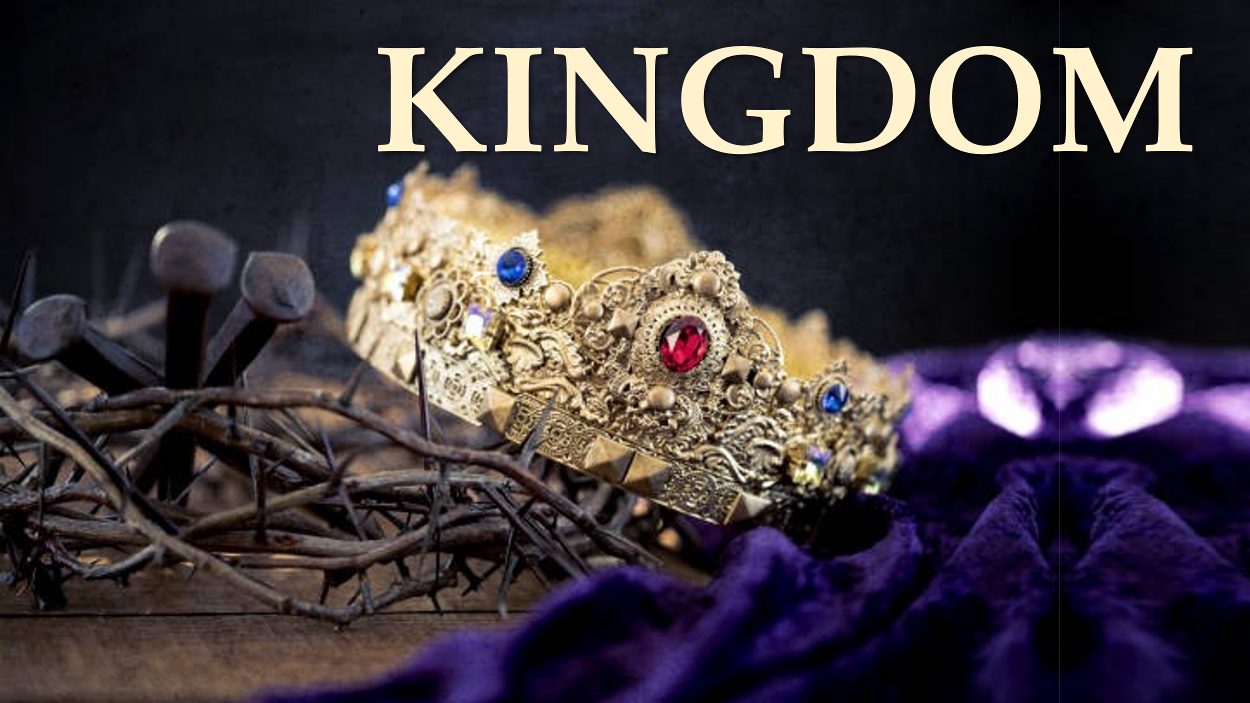

TO CONTINUE THE CONVERSATION
1. What are two ‘take away’ ideas you heard today? Things you want to think about more?

2. Who is on the throne in your life? In your raying, noticing, reflecting this week, call upon King Jesus and seek His grace and guidance.

3. As you reflect on your own life, what relationships, decisions, realties, hopes and dreams might you do well to look at ‘with two eyes’ here and now, and there and not yet?

